WEEK 1: Project Review and Development Planning

INTENDED LEARNING OUTCOME
At the end of this activity, students should be able to:
Develop a comprehensive project implementation plan by reviewing the approved capstone proposal, validating project scope, incorporating panel recommendations, assigning project responsibilities, preparing a project schedule, and establishing project monitoring tools.

OVERVIEW OF WEEK 1 OUTPUTS
By the end of Week 1, each group must submit:
- Panel Recommendation Compliance Matrix
- Project Scope Validation Form
- Work Breakdown Structure (WBS)
- Revised Gantt Chart
- Project Development Plan
- Repository Setup Report
- Adviser Consultation Record

ACTIVITY 1
Review of Panel Recommendations

Purpose
To ensure that all recommendations from the proposal defense have been reviewed and addressed before implementation begins.

Procedure
- Secure a copy of the proposal defense evaluation sheet.
- Review all comments from the panel.
- Discuss as a group how each recommendation will be addressed.
- Complete Form 1.

FORM 1
PANEL RECOMMENDATION COMPLIANCE MATRIX

Instructions
For every recommendation:
- Copy the recommendation exactly as stated by the panel.
- Describe the action that the group will take.
- Identify supporting evidence.
- Mark the status.

No. | Panel Recommendation | Planned Action | Evidence | Status
1 | To include in the Background of the Project the real concern of scenario where a certain individual connecting to public wi-fi and unauthorized hacking was experienced. | Add a real-life scenario in the Background of the Project discussing the risks of connecting to Public Wi-Fi, including a case of unauthorized access/hacking. | This is incorporated on pages 4-5 of the manuscript. | Completed
2 | Revise Specific Objectives, incorporated in the paper. | Revise and refine the specific objectives to improve clarity and alignment with the study. | The updated objectives are presented on pages 9-10 of the manuscript. | Completed
3 | Revise RRL by categorizing related topics. | Revise the RRL by organizing and categorizing sources according to relevant themes. | The organized and categorized RRL are found on pages 15–22 of the manuscript. | Completed
4 | Emphasis on the synthesis the existing study and how the project surpass the existing literature. | Revise the synthesis to emphasize the integration of existing studies and clearly highlight how the proposed system surpasses current literature. | The updated synthesis is reflected on pages 26–29 of the manuscript. | Completed
5 | Revise methodology based on the objectives. | Revise the methodology to ensure alignment with the stated objectives. | The revised methodology is presented on pages 30–43 of the manuscript. | Completed
6 | Define Public Wi-Fi | Add a clear definition of Public Wi-Fi in the manuscript to establish context for the study. | The definition is presented on pages 2-3. | Completed
7 | Use hierarchical numbering format (1.1, 1.2) instead of a, b, c | Reformat objectives using hierarchical numbering to improve clarity and comply with panel instructions. | The revision is reflected on page 9-10 of the manuscript. | Completed
8 | Related studies are summarized individually without direct cross-comparison. A Comparative Analysis table is needed with a "Relevance to the Proposed System" column to show how the study builds on existing literature. | Add and develop Table 1 (Comparative Analysis of Related Studies) with columns for Author/Year, Method/Tool, Threats Detected, Strengths, Limitations, and Relevance to the Proposed System. | Updated table found on pages 25-26. | Completed
9 | TP, FP, TN, and FN definitions are present in the manuscript but not formatted as a properly labeled table, making IDS evaluation criteria unclear for readers and panel reviewers. | Add a titled confusion matrix table ("Table. Confusion Matrix Terms for IDS Evaluation") in Section 3.6 defining TP, FP, TN, FN, Detection Rate, False Positive Rate, and Mean Response Time. | Updated section is on pages 40–43. | Completed
10 | Objective 4 states the False Positive Rate target as "not exceeding 5%", but Chapter III (Sections 3.5 and 3.6) and Chapter IV (Section 4.6.3) do not clearly repeat or apply this benchmark consistently. | Add the explicit benchmark "False Positive Rate target: not exceeding 5%" to Section 3.5 (Evaluation Procedure), Section 3.6 (Data Analysis Techniques), and Section 4.6.3 (Security Metrics) to ensure consistency across all chapters. | See pages 38, 40, and 62 of the manuscript. | Completed
11 | Attack simulation procedures do not specify the exact number of trials per attack type, nor is there a structured testing matrix linking each attack to the tool used, expected detection, severity level, and metric recorded. | Specify 5 trials per attack type in Section 3.5 (Alpha Testing) and Section 4.6 (Attack Simulation). Add a testing matrix in Section 4.6.3: Attack Type → Tool Used → Expected Detection → Severity → Metric Recorded. | See pages 38, 60 and 62-65. | Completed
12 | Metrics of measurement and success were not included in the objectives | Incorporate measurable indicators of success into the objectives to ensure clarity and evaluability. | The revised objectives are presented on page 10, 4.1-4.3 of the specific objectives. | Completed
13 | Identification of devices connected in terms of? | Clarify the identification of devices connected to the public Wi-Fi network by specifying the parameters used like IP address, MAC address, and device-related information. | The revised objective is reflected on page 9, 1.1 of the specific objectives. | Completed
14 | Accuracy – How to measure threshold value? | Clarify the basis for threshold values used in threat detection and defined how accuracy is measured using detection rate, false positive rate, and response time. | The revisions are reflected on page 10, no.4 of the specific objectives. | Completed
15 | Identify network behavior | Address the identification of network behavior by incorporating features for capturing, analyzing, and monitoring real-time network activities, particularly under Objectives 1.3 and 1.4. | These enhancements are reflected on page 9 of the manuscript. | Completed
16 | Emphasize specific threats (MITM, ARP poisoning, MAC spoofing, port scanning) | Add a clear definition and explanation of the four major network threats in the Background section to clearly emphasize their relevance to public Wi-Fi security. | The definition and explanation are reflected on page 3, 2nd paragraph. | Completed
17 | Include actual damages and risks based on literature and actual data | Incorporate discussion of real-world consequences such as identity theft, financial loss, and unauthorized access based on news reports and literature. | This is incorporated on page 4. | Completed
18 | Show how accuracy is tested | Include testing procedures describing how detection accuracy, false positive rate, and response time are evaluated using simulated attacks. | These inclusions are reflected in phase 3, page 31. | Completed

ACTIVITY 2
Project Scope Validation

Purpose
To verify that the approved project remains feasible and aligned with client requirements.
Procedure
- Review Chapter 1 and Chapter 3.
- Verify all objectives.
- Review scope and limitations.
- Identify any requested modifications.
- Complete Form 2.

FORM 2
PROJECT SCOPE VALIDATION FORM

Instructions
Check whether each component remains valid.

A. Objectives Validation
Objective | Still Applicable? | Remarks
Objective 1: Design and develop a real-time network monitoring system | Yes | Covers device identification by IP address, MAC address, hostname, vendor, and connection status; logging of connection and disconnection events; packet capture and analysis using Npcap and Scapy; detection of abnormal network behavior such as ARP inconsistencies, MAC spoofing, and unusual TCP patterns; and real-time alerts with audible and visual indicators and mitigation recommendations. Still applicable — all sub-objectives (1.1–1.5) remain feasible on a Windows host machine.
Objective 2: Develop a web-based monitoring dashboard | Yes | Displays real-time network activity and device information, shows detected threats with severity classification, and supports filtering, logging, and report generation. Still applicable — Flask and Flask-SocketIO remain the approved stack, and the dashboard runs on localhost (127.0.0.1) as stated in the Scope and Limitations.
Objective 3: Implement a threat detection and classification mechanism for Man-in-the-Middle attacks, ARP poisoning, MAC spoofing, and port scanning | Yes | Rule-based detection using gateway MAC anomaly checking, IP-to-MAC mapping conflict detection, duplicate MAC monitoring, and a TCP connection threshold of more than 15 unique destination ports within 30 seconds. Still applicable — the detection scope remains limited to the four approved threat types; no additional attack types were added.
Objective 4: Evaluate the system's performance using Detection Rate, False Positive Rate, and Mean Response Time | Yes | Targets are a Detection Rate of 1.0, a False Positive Rate not exceeding 5%, and a Mean Response Time of 5–15 seconds. Still applicable — these benchmarks are now stated consistently in Sections 3.5, 3.6, and 4.6.3 following panel recommendation No. 10.
Objective 5: Conduct controlled network security testing through authorized attack simulation | Yes | Covers validation of packet capture accuracy, assessment of the rule-based detection mechanism, evaluation of severity classification and real-time alert generation, and measurement of response time and detection consistency across trials. Still applicable — five trials per attack type will be conducted within the authorized test network at JR Inasal House – Alicia Branch, with permission from establishment management.

B. Requirements Validation
Requirement | Validated | Remarks
Functional Requirements | ☑ | Validated. Device discovery and identification (IP address, MAC address, hostname, vendor, status), connection and disconnection logging, real-time packet capture, rule-based detection of the four target threats, severity classification, audible and visual alerts, mitigation recommendations, log filtering, report export, and administrator authentication.
Non-Functional Requirements | ☑ | Validated. Detection Rate target of 1.0, False Positive Rate not exceeding 5%, and Mean Response Time of 5–15 seconds; passive and non-disruptive monitoring; localhost-only dashboard access; bcrypt-hashed credentials; overall quality assessed using ISO/IEC 25010:2011 characteristics.
User Requirements | ☑ | Validated. Primary users are the Manager and two frontline staff of JR Inasal House – Alicia Branch. The dashboard uses plain-language alerts and mitigation guidance so it can be operated without deep technical expertise.
Hardware Requirements | ☑ | Validated. Windows-based administrator monitoring computer with a wireless adapter capable of promiscuous mode; Kali Linux machine for authorized attack simulation; the establishment's existing wireless router / access point; client devices (smartphones and laptops).
Software Requirements | ☑ | Validated. Python 3, Flask, Flask-SocketIO, Scapy, Npcap, SQLite, and a web browser. Authorized testing tools: Nmap, arpspoof (dsniff), arping, and ip link on Kali Linux.

C. Scope Changes
List proposed modifications.
Proposed Change | Reason | Adviser Approval
No change in the approved scope of the study. | The general and specific objectives, the four target threat types, the deployment site, and the evaluation framework all remain feasible and unchanged after the proposal defense. | For adviser confirmation
Addition of dashboard threat analytics (Chart.js visualization) and a threat acknowledge / resolve function. | Improves usability and supports the ISO/IEC 25010 Usability and Functional Suitability evaluation. It does not expand the detection scope or add new attack types. | For adviser confirmation
Addition of application-layer security hardening (CSRF protection and login rate limiting). | Strengthens administrator access control consistent with the ISO/IEC 27001:2022 principles already cited in the manuscript. | For adviser confirmation

ACTIVITY 3
Work Breakdown Structure Development

Purpose
To organize all project activities and distribute responsibilities among team members.

Procedure
- List all tasks needed to complete the project.
- Group similar tasks together.
- Assign responsible members.
- Estimate completion dates.
- Complete Form 3.
FORM 3
WORK BREAKDOWN STRUCTURE (WBS)

Instructions
Break down project activities into smaller work packages.

Major Deliverable | Task | Assigned Member | Due Week
Front-End Development | Login Interface | Bueno, Jannces G. | Week 2
Front-End Development | Dashboard layout and navigation structure | Bueno, Jannces G. | Week 2
Front-End Development | Live device monitoring table (IP, MAC, hostname, vendor, status) | Bueno, Jannces G. | Week 3
Front-End Development | Threat intelligence log panel with severity color coding | Bueno, Jannces G. | Week 4
Front-End Development | Network connection log and administrator activity log views | Bueno, Jannces G. | Week 4
Front-End Development | Real-time alert interface (audible alarm and color-flash indicator) | Bueno, Jannces G. | Week 5
Front-End Development | Threat log filtering, report export, and change password interface | Bueno, Jannces G. | Week 5
Back-End Development | Authentication Module (bcrypt hashing, session control, login rate limiting, CSRF protection) | Bueno, Jannces G. | Week 2
Back-End Development | Packet capture module using Scapy and Npcap | Bueno, Jannces G. | Week 3
Back-End Development | Device registry, liveness prober, and connection event logging | Bueno, Jannces G. | Week 3
Back-End Development | Rule-based detection engine for MITM, ARP poisoning, MAC spoofing, and port scanning | Bueno, Jannces G. | Weeks 4–6
Back-End Development | Severity classification and mitigation recommendation mapping | Bueno, Jannces G. | Week 6
Back-End Development | Flask-SocketIO real-time event push and alert dispatch | Bueno, Jannces G. | Week 6
Back-End Development | Report export endpoint and administrator action logging | Bueno, Jannces G. | Week 7
Database Development | Database Creation (devices, threats, connection_log, admin_users, admin_log) | Bueno, Jannces G. | Week 2
Database Development | Schema initialization script and threat deduplication logic | Bueno, Jannces G. | Week 3
Database Development | Data integrity checking and database backup procedure | Bueno, Jannces G. | Week 7
Testing | Unit Testing of each detection rule | Gulla, Ma. Leonora M. | Week 7
Testing | Integration and smoke testing of the dashboard and back-end modules | Gulla, Ma. Leonora M. | Week 8
Testing | Baseline normal traffic observation for True Negative and False Positive Rate computation | Gulla, Ma. Leonora M. | Week 9
Testing | Alpha Testing – five authorized attack trials per attack type using Kali Linux | Gulla, Ma. Leonora M. | Weeks 9–11
Testing | Beta Testing – on-site operational validation at JR Inasal House – Alicia Branch | Gulla, Ma. Leonora M. | Weeks 12–13
Evaluation | Guided demonstration and user evaluation with the Manager and two frontline staff | All members | Week 14
Evaluation | Computation of Detection Rate, False Positive Rate, Mean Response Time, and Weighted Mean | Bueno, Jannces G. | Week 15
Deployment | Installation on the administrator machine and database initialization | Bueno, Jannces G. | Week 13
Deployment | Environment preparation (Python 3, Flask, Scapy, Npcap, dependencies) | Bueno, Jannces G. | Week 12
Deployment | Verification of all system features in the live network environment | All members | Week 13
Documentation | User Manual | Attaban, Quincy Joy B. | Week 15
Documentation | Weekly activity forms and progress documentation | Attaban, Quincy Joy B. | Weeks 1–18
Documentation | Preparation and expert validation of the ISO/IEC 25010 evaluation questionnaire | Attaban, Quincy Joy B. | Week 13
Documentation | Chapter IV–V write-up (results, discussion, conclusions, and recommendations) | Attaban, Quincy Joy B. | Weeks 15–16
Documentation | Preparation of mock defense presentation materials | Attaban, Quincy Joy B. | Week 16
Documentation | Final manuscript revision and final defense preparation | All members | Weeks 17–18

Team Verification
All members must sign below:


ACTIVITY 4
Gantt Chart Preparation

Purpose
To establish a semester-long implementation schedule.

Procedure
- Use the completed WBS.
- Identify project milestones.
- Assign target weeks.
- Prepare the schedule.
- Complete Form 4.

FORM 4
GANTT CHART SUBMISSION FORM
Instructions
Indicate when each task will be performed.
Activities | W1 | W2 | W3 | W4 | W5 | W6 | W7 | W8 | W9 | W10 | W11 | W12 | W13 | W14 | W15 | W16 | W17 | W18
Development |  | X | X | X | X | X | X
Testing |  |  |  |  |  |  | X | X | X | X | X | X | X
Deployment |  |  |  |  |  |  |  |  |  |  |  | X | X
Evaluation |  |  |  |  |  |  |  |  |  |  |  |  |  | X | X
Documentation | X | X | X | X | X | X | X | X | X | X | X | X | X | X | X | X | X | X

Milestone Schedule
Milestone | Target Week
Alpha Version | Week 9
Prototype Presentation | Week 10
Beta Version | Week 12
Agency Immersion | Weeks 12–13
Deployment | Week 13
Evaluation | Weeks 14–15
Mock Defense | Week 16
Final Defense | Week 18

ACTIVITY 5
Development Planning

Purpose
To prepare the overall implementation strategy.
Procedure
- Determine development methodology.
- Identify technologies.
- Assign project roles.
- Identify risks.
- Complete Form 5.

FORM 5
PROJECT DEVELOPMENT PLAN

A. Team Roles
Team Member | Role | Responsibilities
Bueno, Jannces G. | Project Leader / Lead Developer | Overall project management and task monitoring; development of the front-end dashboard, back-end modules, packet capture, rule-based detection engine, severity classification, authentication and security controls, and the SQLite database; system deployment and computation of the evaluation metrics; primary liaison with the adviser and the establishment.
Attaban, Quincy Joy B. | Documentation | Preparation and maintenance of all project documentation, including the weekly activity forms, the ISO/IEC 25010 evaluation questionnaire, the user manual, the manuscript write-up, and the mock and final defense presentation materials.
Gulla, Ma. Leonora M. | Quality Assurance | Unit, integration, and smoke testing of all modules; baseline normal traffic observation; conduct of the authorized attack simulations during Alpha Testing and on-site Beta Testing; recording of results in the Technical Testing Log.

B. Development Methodology
□ Agile
□ Scrum
☑ Waterfall – specifically the V-Model, in which every development stage is paired with a corresponding testing stage (Requirement Analysis, System Design, Implementation, Testing, and Deployment), as specified in Section 3.2 of the approved manuscript.
□ Incremental

C. Development Tools
Category | Tool
Programming Language | Python 3 (back-end); HTML, CSS, and JavaScript (front-end)
Framework | Flask and Flask-SocketIO; Scapy with Npcap for packet capture; Chart.js for dashboard visualization
Database | SQLite 3 (wifi_guardian.db)
IDE | Visual Studio Code
Repository | GitHub (https://github.com/jannces/Capstone2)

D. Risk Management Plan
Risk | Probability | Impact | Mitigation
Limited packet visibility caused by access point client isolation or a wireless adapter that does not fully support promiscuous mode. | High | High | Verify adapter capability before deployment; supplement Scapy sniffing with ARP probing and DHCP/mDNS/LLMNR discovery; document visibility limits as a stated limitation of the study.
False positives from legitimate MAC or IP address changes, such as device MAC randomization or DHCP lease renewal. | Medium | Medium | Conduct baseline normal traffic observation; tune the detection thresholds; apply the five-minute deduplication window; monitor the False Positive Rate against the ≤ 5% benchmark.
Disruption of the establishment's normal operations or customer connectivity during on-site testing. | Low | High | Keep all monitoring passive; secure written permission from management; schedule testing during off-peak hours; prepare rollback procedures to restore normal network conditions immediately.
Loss of source code, database records, or documentation due to hardware failure, or schedule delays caused by member unavailability. | Medium | High | Commit to the GitHub repository after every working session; keep versioned backups of the database and manuscript; follow the WBS with buffer weeks and hold twice-weekly team meetings.

E. Communication Plan
Activity | Schedule
Team Meeting | Twice a week (Tuesday and Friday) for progress review and task assignment, with daily coordination through the group chat.
Adviser Consultation | Weekly consultation with the adviser, Romero Dante C. Salum, DIT, or as scheduled based on his availability; each session is recorded in the Adviser Consultation Record.
Client Coordination | Coordination with the Manager of JR Inasal House – Alicia Branch at least twice a month, with on-site visits during deployment, beta testing, and user evaluation.

ACTIVITY 6
Repository Setup

Purpose
To establish version control and project collaboration mechanisms.
Procedure
- Create repository.
- Create project folder structure.
- Add all members.
- Commit initial files.
- Complete Form 6.

FORM 6
REPOSITORY SETUP REPORT

Repository Information
Repository Name: Capstone2

Repository URL: https://github.com/jannces/Capstone2

Member Access
Member | Access Granted
Bueno, Jannces G. | Yes
Attaban, Quincy Joy B. | Yes
Gulla, Ma. Leonora M. | Yes

Required Screenshots
Attach:
□ Repository Homepage
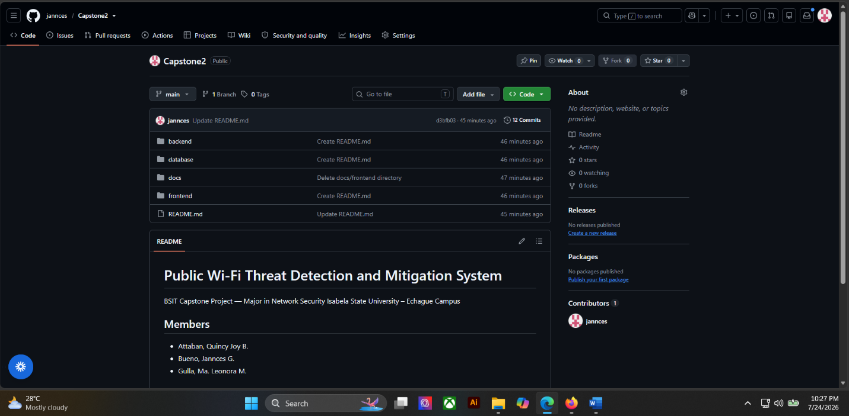

□ Team Members
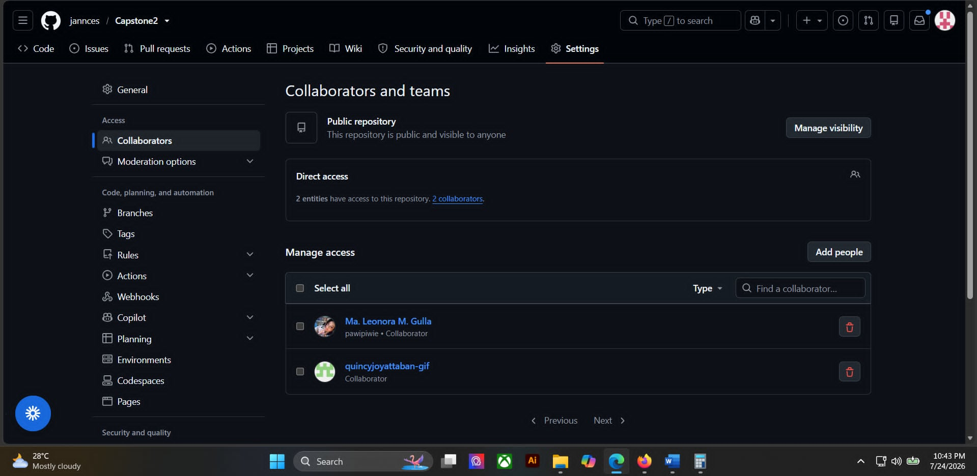

□ Folder Structure
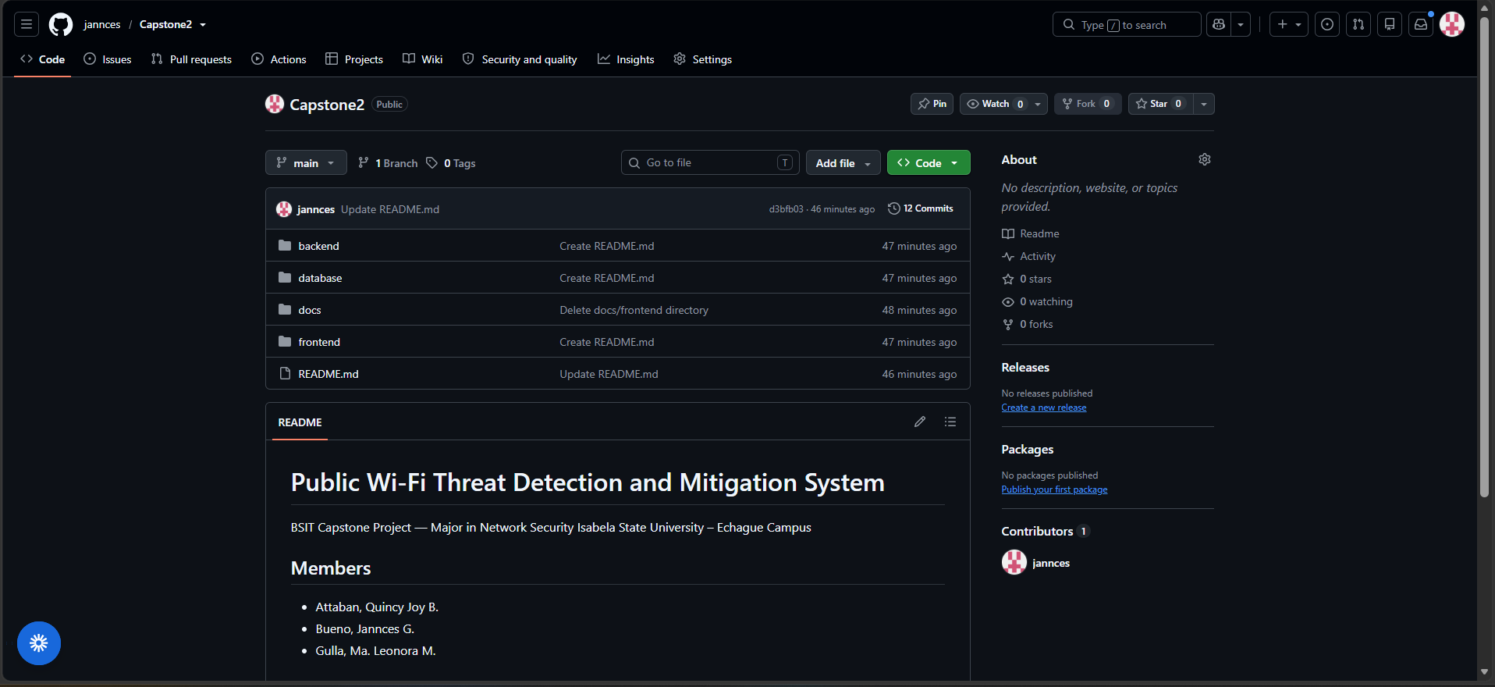

□ Initial Commit
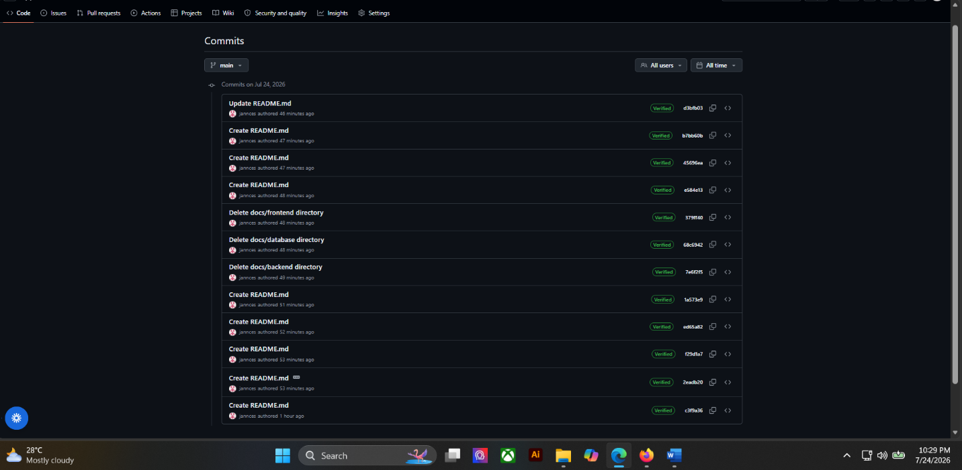

Repository Structure
List folders created.
Folder Name | Purpose
/docs | Documentation – manuscript, weekly forms, diagrams, and user manual
/database | Database Scripts – SQLite schema, initialization script, and backups
/frontend | Interface Development – HTML, CSS, JavaScript, and dashboard templates
/backend | Server-side Development – Flask application, packet capture, and detection engine

ACTIVITY 7
Adviser Consultation

Purpose
To validate project readiness before development starts.

Procedure
- Present all Week 1 outputs.
- Discuss project schedule.
- Discuss risks and responsibilities.
- Record adviser recommendations.
- Complete Form 7.
